1. Refactor the refactoring-homework.html web page and make its HTML semantic
2. Create a web page using semantic HTML by the design :

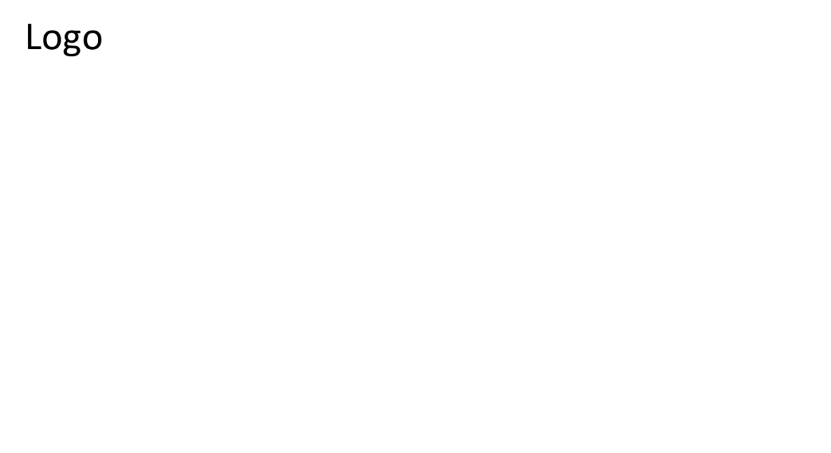

Welcome to Our Web Site

* Nav item 1
* Nav item 1
* Nav item 1
* Nav item 1

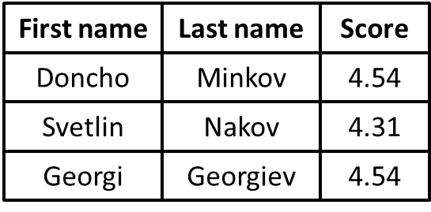

3. Create a web page using semantic HTML by the design :  
